**TUGAS PRAKTEK JWD FR.IA.02**

**Nama : Hari Wijaya**

**JUNIOR WEB DEVELOPER**

**Link Akses Tugas Praktek**

<https://drive.google.com/drive/folders/1RI26vXMODxNr99ORx7lexQn5j9AHCsFQ>

1. **Mengimplementasikan *User Interface***

* **Tampilan Awal Beasiswa**

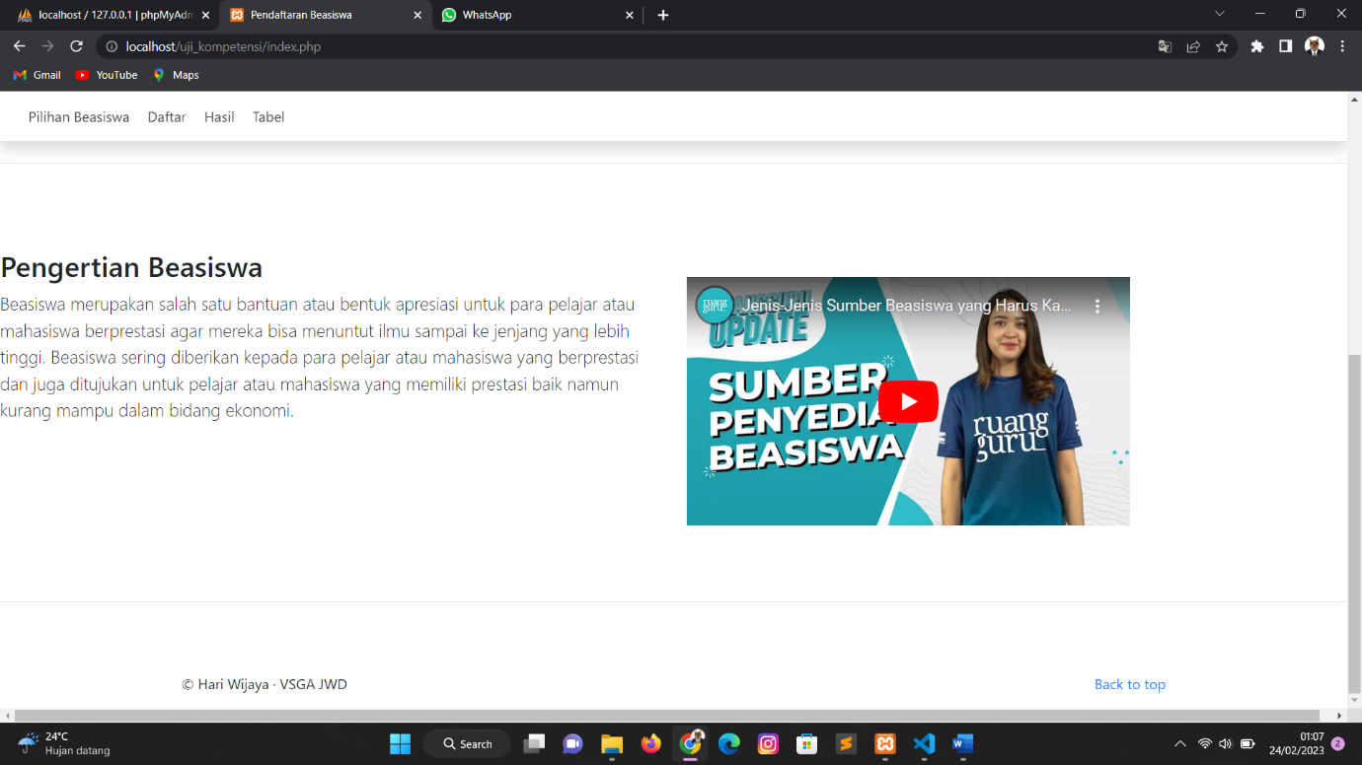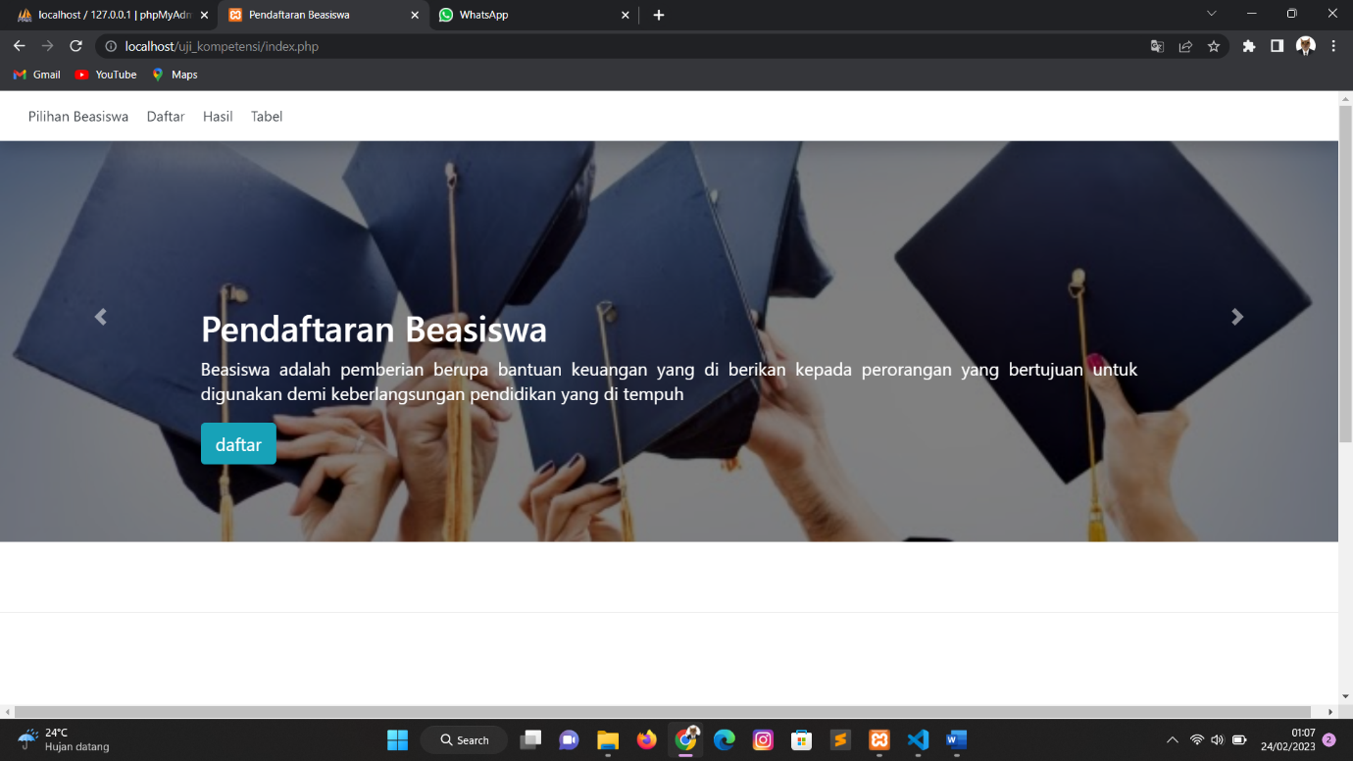

* **Tampilan Form Pendaftaran Beasiswa**

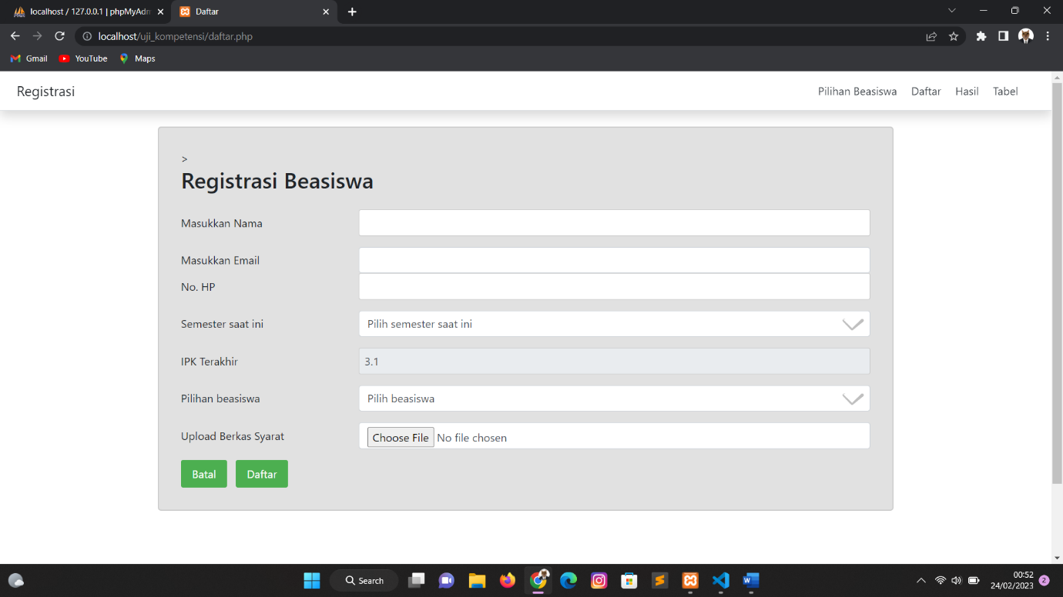

* **Tampilan Hasil Data Beasiswa**

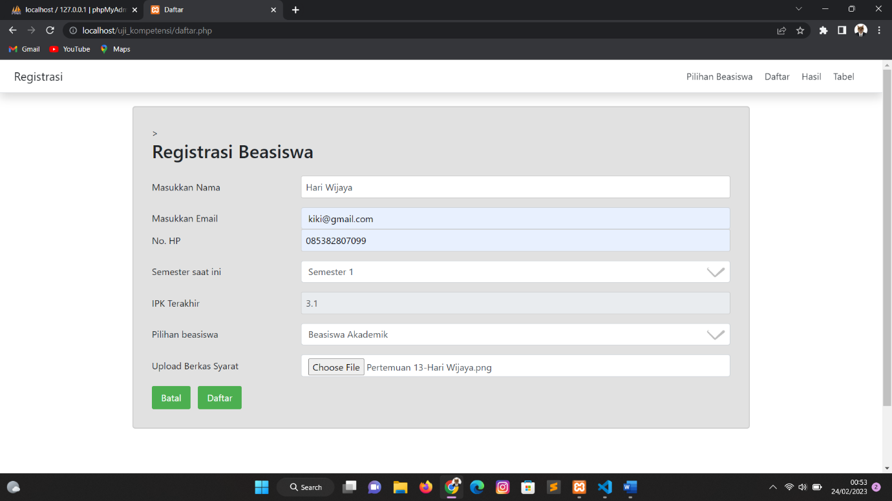

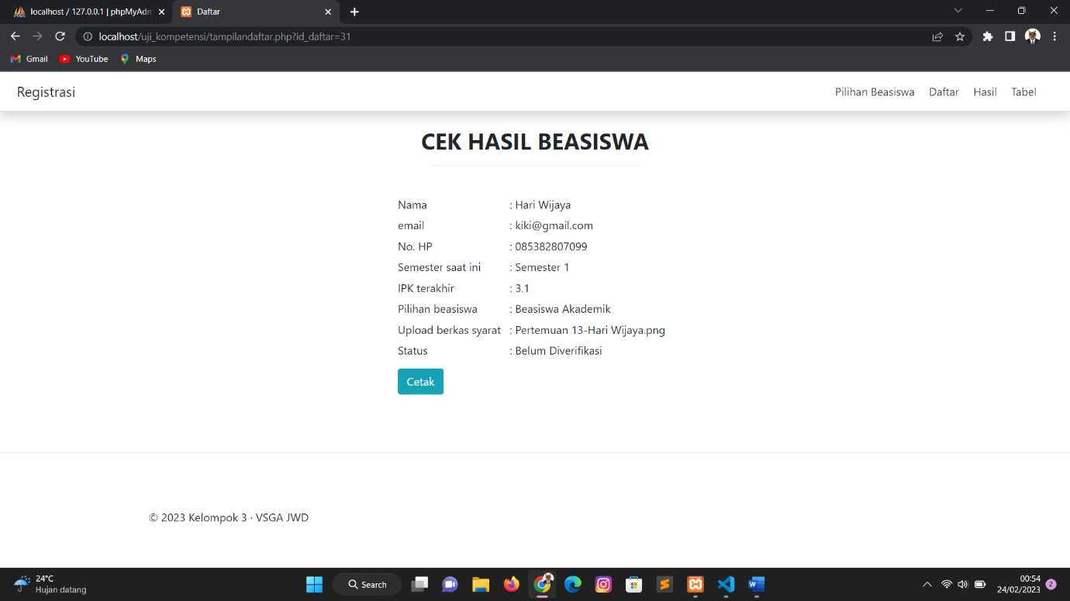

1. **Menerapkan Perintah Eksekusi Bahasa Pemrograman Berbasis Teks,Grafik dan Multimedia**

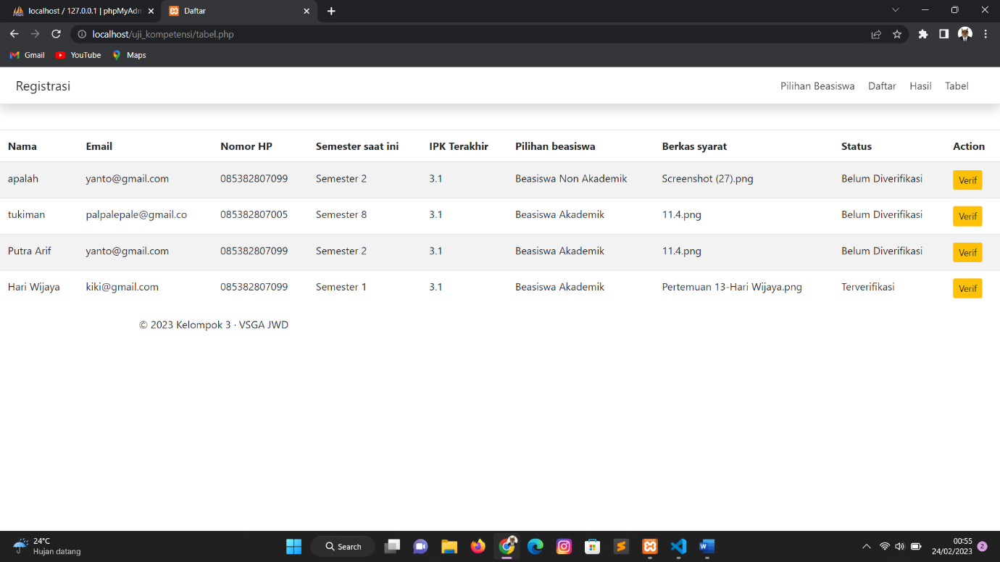

**Source Code tampilandaftar.php**

<?php

include 'koneksi.php';

$uji_kompetensi = mysqli_query($db, "SELECT * FROM uji_kompetensi WHERE id_daftar = '$_GET[id_daftar]'");

$d = mysqli_fetch_object($uji_kompetensi);

?>

<!doctype html>

<html lang="en">

<head>

    <meta charset="utf-8">

    <meta name="viewport" content="width=device-width, initial-scale=1, shrink-to-fit=no">

    <meta name="generator" content="Hugo 0.101.0">

    <title>Daftar</title>

    <link rel="stylesheet" type="text/css" href="style-form.css" />

    <!-- Bootstrap core CSS -->

    <link href="css/bootstrap.min.css" rel="stylesheet">

    <!-- Custom styles for this template -->

    <link href="css/carousel.css" rel="stylesheet">

    <style>

        .bd-placeholder-img {

            font-size: 1.125rem;

            text-anchor: middle;

            -webkit-user-select: none;

            -moz-user-select: none;

            -ms-user-select: none;

            user-select: none;

        }

        #wisata {

            padding-top: 95px;

            margin-top: -95px;

        }

        @media (min-width: 768px) {

            .bd-placeholder-img-lg {

                font-size: 3.5rem;

            }

        }

        @media print {

            body * {

                visibility: hidden;

            }

            #cetak-tiket,

            #cetak-tiket * {

                visibility: visible;

            }

            #tombol-cetak {

                visibility: hidden;

            }

            #cetak-tiket {

                left: 0px;

                top: 0px;

                position: absolute;

            }

            p {

                page-break-before: always;

            }

        }

    </style>

</head>

<body>

<div class="d-flex flex-column flex-md-row align-items-center p-3 px-md-4 bg-white border-bottom shadow fixed-top ">

    <h5 class="my-0 mr-md-auto font-weight-normal">Registrasi</h5>

    <nav class="my-2 my-md-0 mr-md-3">

      <a class="p-2 text-dark" href="index.php">Pilihan Beasiswa</a>

      <a class="p-2 text-dark" href="daftar.php">Daftar</a>

      <a class="p-2 text-dark" href="tampilandaftar.php">Hasil</a>

      <a class="p-2 text-dark" href="tabel.php">Tabel</a>

    </nav>

  </div>

    <main role="main">

        <div style="margin-top: 5rem;">

            <div id="cetak-tiket">

                <h2 align="center"><b>CEK HASIL BEASISWA</b></h2>

                <hr width="300"><br>

                <table align="center" cellpadding="3" align="center" width="400">

                    <tr>

                        <td>Nama</td>

                        <td>: <?php echo @$d->nama ?></td>

                    </tr>

                    <tr>

                        <td>email</td>

                        <td>: <?php echo @$d->masukkan_email ?></td>

                    </tr>

                    <tr>

                        <td>No. HP</td>

                        <td>: <?php echo @$d->no_hp ?></td>

                    </tr>

                    <tr>

                        <td>Semester saat ini</td>

                        <td>: <?php echo @$d->semester_saat_ini ?></td>

                    </tr>

                    <tr>

                        <td>IPK terakhir</td>

                        <td>: <?php echo @$d->ipk_terakhir ?> </td>

                    </tr>

                    <tr>

                        <td>Pilihan beasiswa</td>

                        <td> : <?php echo @$d->pilihan_beasiswa ?> </td>

                    </tr>

                    <tr>

                        <td>Upload berkas syarat</td>

                        <td>:  <?php echo @$d->pilih_file_untuk_upload ?></td>

                    </tr>

                    <tr>

                        <td>Status</td>

                        <td>:  <?php echo @$d->status_ajuan ?></td>

                    </tr>

                    <tr>

                        <td>

                            <a class="btn btn-info mt-2" id="tombol-cetak" href="javascript:if(window.print)window.print()">Cetak</a>

                        </td>

                    </tr>

                </table>

            </div>

        </div>

        <hr class="featurette-divider">

        <!-- /END THE FEATURETTES -->

        </div><!-- /.container -->

        <!-- FOOTER -->

        <footer class="container">

            <p>&copy; 2023 Kelompok 3 &middot; VSGA JWD</p>

        </footer>

    </main>

    <script src="script.js"></script>

    <script src="js/jquery.slim.min.js"></script>

    <script src="js/bootstrap.bundle.min.js" integrity="sha384-Fy6S3B9q64WdZWQUiU+q4/2Lc9npb8tCaSX9FK7E8HnRr0Jz8D6OP9dO5Vg3Q9ct" crossorigin="anonymous"></script>

</body>

</html>

1. **Menyusun Fungsi File atau Sumber Daya Pemrograman yang Lain dalam Organisasi yang rapi**

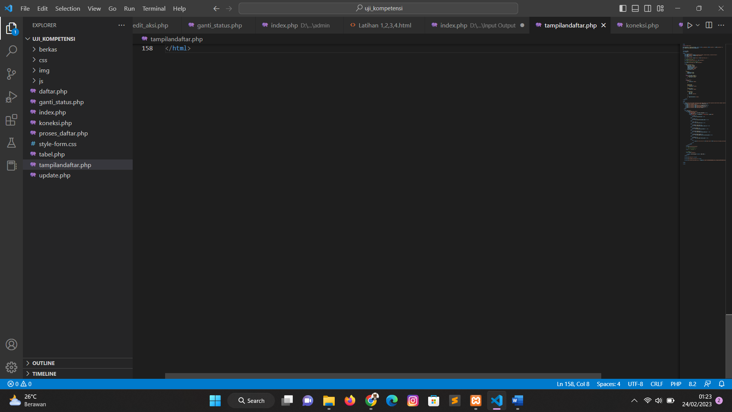

1. **Menulis Kode dengan Prinsip Guidelines dan Best Pratices**
2. <?php
3. //koneksi ke database
4. include 'koneksi.php';
5. $nama = $_POST['nama'];
6. $masukkan_email = $_POST['masukkan_email'];
7. $no_hp = $_POST['no_hp'];
8. $semester_saat_ini = $_POST['semester_saat_ini'];
9. $ipk_terakhir = $_POST['ipk_terakhir'];
10. $pilihan_beasiswa = $_POST['pilihan_beasiswa'];
11. // $pilih_file_untuk_upload = $_POST['pilih_file_untuk_upload'];
12. $status = 'Belum Diverifikasi';
13. // ambil data file
14. $namaFile = $_FILES['pilih_file_untuk_upload']['name'];
15. $namaSementara = $_FILES['pilih_file_untuk_upload']['tmp_name'];
16. // tentukan lokasi file akan dipindahkan
17. $dirUpload = "berkas/";
18. // pindahkan file
19. $terupload = move_uploaded_file($namaSementara, $dirUpload . $namaFile);
20. $uji_kompetensi = mysqli_query($db, "INSERT INTO uji_kompetensi VALUES ('', '$nama','$masukkan_email','$no_hp','$semester_saat_ini','$ipk_terakhir','$pilihan_beasiswa','$namaFile','$status')");
21. if ($uji_kompetensi) {
22. echo "<script> alert ('Data Berhasil Disimpan')</script>";
23. $last_id = mysqli_insert_id($db);
24. header("refresh:0;tampilandaftar.php?id_daftar=" . $last_id);
25. } else {
26. echo "<script> alert ('Data Tidak Berhasil Disimpan')</script>";
27. echo mysqli_error($db);
28. }

**5. Mengimplementasikan Pemrograman terstruktur**

    </tr>

  </thead>

  <tbody>

  <?php

    include 'koneksi.php';

    $query = "SELECT * FROM uji_kompetensi";

    $result = mysqli_query($db, $query);

    if (!$result) {

      die("Query Error: " . mysqli_errno($db) .

        " - " . mysqli_error($db));

    }

    while ($row = mysqli_fetch_array($result)) {

    ?>

      <tr>

        <td> <?= $row['nama']; ?></td>

        <td> <?= $row['masukkan_email']; ?></td>

        <td> <?= $row['no_hp']; ?></td>

        <td> <?= $row['semester_saat_ini']; ?></td>

        <td> <?= $row['ipk_terakhir']; ?></td>

        <td> <?= $row['pilihan_beasiswa']; ?></td>

        <td> <?= $row['pilih_file_untuk_upload']; ?></td>

        <td> <?= $row['status_ajuan']; ?></td>

**6. Menggunakan Library atau komponen Pre-Existing**

<script src="script.js"></script>

  <script src="js/jquery.slim.min.js"></script>

  <script src="js/bootstrap.bundle.min.js" integrity="sha384-Fy6S3B9q64WdZWQUiU+q4/2Lc9npb8tCaSX9FK7E8HnRr0Jz8D6OP9dO5Vg3Q9ct" crossorigin="anonymous"></script>

  <script>

    const ipk = 3.1;

    document.getElementById("ipk_terakhir").value = ipk;

    let formbeasiswaDiv = document.getElementById('formbeasiswa');

    let uploadDiv = document.getElementById('upload');

    let DaftarButton = document.getElementById('Daftar');

    let formBeasiswaHTML = '<div class="row"> <label for="pilihan_beasiswa" class="col-sm-3 col-form-label">Pilihan beasiswa</label><div class="col-sm-9"><select class="form-control" id="pilihan_beasiswa" name="pilihan_beasiswa" required><option value="">Pilih beasiswa</option><option value="Beasiswa Akademik">Beasiswa Akademik</option><option value="Beasiswa Non Akademik">Beasiswa Non Akademik</option></select></div></div>';

    let uploadHTML = '<div class="row"> <label for="pilih_file_untuk_upload" class="col-sm-3 col-form-label">Upload Berkas Syarat</label><div class="col-sm-9"><input type="file" class="form-control" id="pilih_file_untuk_upload" name="pilih_file_untuk_upload" required></div></div>';

  if (ipk >= 3.0){

   formbeasiswaDiv.innerHTML = formBeasiswaHTML;

   uploadDiv.innerHTML = uploadHTML;

   DaftarButton.disabled= false;

  } else if (ipk <= 3.0) {

    DaftarButton.disabled= true;

  }

  </script>

**Link Akses Tugas Praktek**

<https://drive.google.com/drive/folders/1RI26vXMODxNr99ORx7lexQn5j9AHCsFQ>